**HACKATHONS**

**ROBOTHON-2023 Finals**

**Date: June 21, 2023**

**Venue: Jyothy Institute of Technology, Bengaluru**

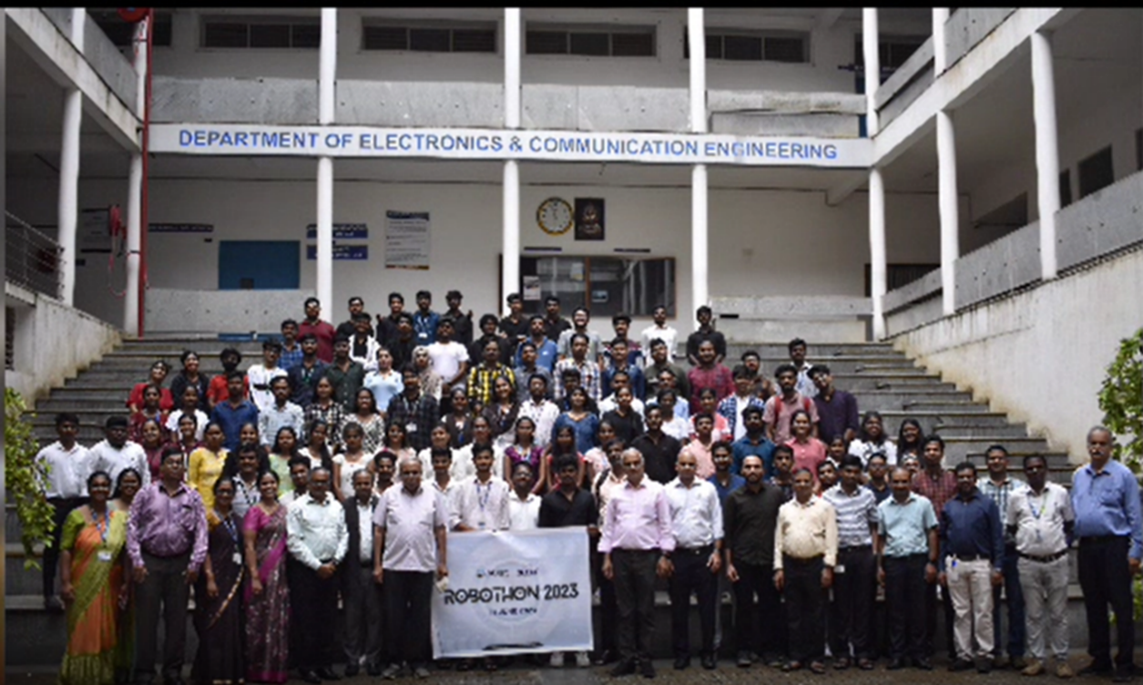

BITES in association with Skyfi Labs and Jyothy Institute of Technology (JIT), Bengaluru organised a Hackathon “RoboThon 2023” on June 21st, Wednesday.

The objective of the program is to get the insights about the technologies used in IoT and to implement & innovate it in the academia. The inaugural session was hosted by Dr Rekha, Training & Placement Officer, JIT with Dr Selvan, Co-chairman, BITES and Dr Gopalakrishna, Principal, JIT addressed the audience and urged the audience to follow and nourish their interest in IoT. Mrs Jyothi H L, Program Director, BITES gave info about BITES.

Around 100 teams were registered for the event, top 20 teams were selected by the Jury to present their prototype on July 21, 2023. The theme “Smart Cities” was given to the teams 3 days prior to the event to build their project.

Immediately after inauguration, the student teams assembled in a seminar hall and started assembling their projects. Staff from JIT, Skyfi Labs and BITES provided the required support to the student teams.

After Lunch session, the Jury Members Prof. Suresh Sundaram, Associate Professor Dept of Aerospace, IISc Bangalore, Mr. Pavan, IoT Specialist, SKYFI Labs, Mr. Basavaraj P N, Senior Robotics Engineer, BOSCH Global Software Technologies, Mr. Manjunath. S. Patil, AIML and Robotics Engineer, BOSCH Global Software Technologies started the evaluation. Each team were given 10-15 minutes to demonstrate their project idea. The process was completed by 6 PM.

After the High-tea, a group photo session was held followed by the valedictory ceremony. Following are the winner details

WINNER:

Team Robo Rebels from Ballari Institute of Technology and Management

(Cash Award of 25,000/- and a Certificate)

RUNNER UPS

FIRST RUNNER UP: Team “Arduino Based Child Rescue System from Open Borewell” from Government Engineering College Talakal

(Cash Award of 15,000/- and a Certificate)

SECOND RUNNER UP 1: Team “Blinders” from Basaveshwar Engineering college Bagalkote

(Cash Award of 10,000/- and a Certificate)

SECOND RUNNER UP 2: Team “Urban” from Jyothy Institute of Technology, Bengaluru

(Cash Award of 10,000/- and a Certificate)

The Jury member Prof. Suresh, IISc offered a two months internship to Nitish Kumar, a third-year student from Ballari Institute and Management at Aerospace Department, IISc in recognition of his amazing passion to excel while demonstrating his project idea.